MATH 4753 Laboratory 1

Introduction to R

In this lab you will learn the basics of R. This program is free and you are encouraged to obtain a copy for your Mac, PC or Linux machine. Install it and then download and install R studio (this is a nice front end to R and is also free).

# Objectives

In this lab you will learn how to:

1. Read data into R.
2. Create data in R.#
3. Manipulate data frames.
4. Create vectors.
5. Create matrices.
6. Create tables.
7. Create barplots.
8. Create pie charts.
9. Create boxplots.
10. Create scatter plots.
11. Be familiar with R markdown and knitting documents

### Tasks

There are a number of front-ends for R

We will however use Rstudio for the course but you may trial other front ends as you have time.

All answers to questions should be written up in R markdown and then knitted into an html. Save and place the .Rmd, and .html files in the dropbox when completed.

**Only the html file will be graded** (the rmd document will be viewed occasionally to help with coding problems)

* Task 1
  + Download from CANVAS the zipped data files, “Dataxls”
  + Unzip the contents into a directory on your desktop (call it LAB1)
  + Download the file “lab1.r”
  + Place this file with the others in LAB1.
  + Start Rstudio
  + Open “lab1.r” from within Rstudio.
  + Go to the “session” menu within Rstudio and “set working directory” to where the source files are located.
  + Obtain the working directory by issuing the command getwd():
* Task 2
  + Find the file “DDT.xls” inside LAB1
  + Open it in Excel
  + Save As type CSV(comma delimited) “*.csv”
  + Use read.table(), read.csv() or the menu on Rstudio to read the data into R, this function will already be available within the script lab1.r which you have opened in Rstudio.

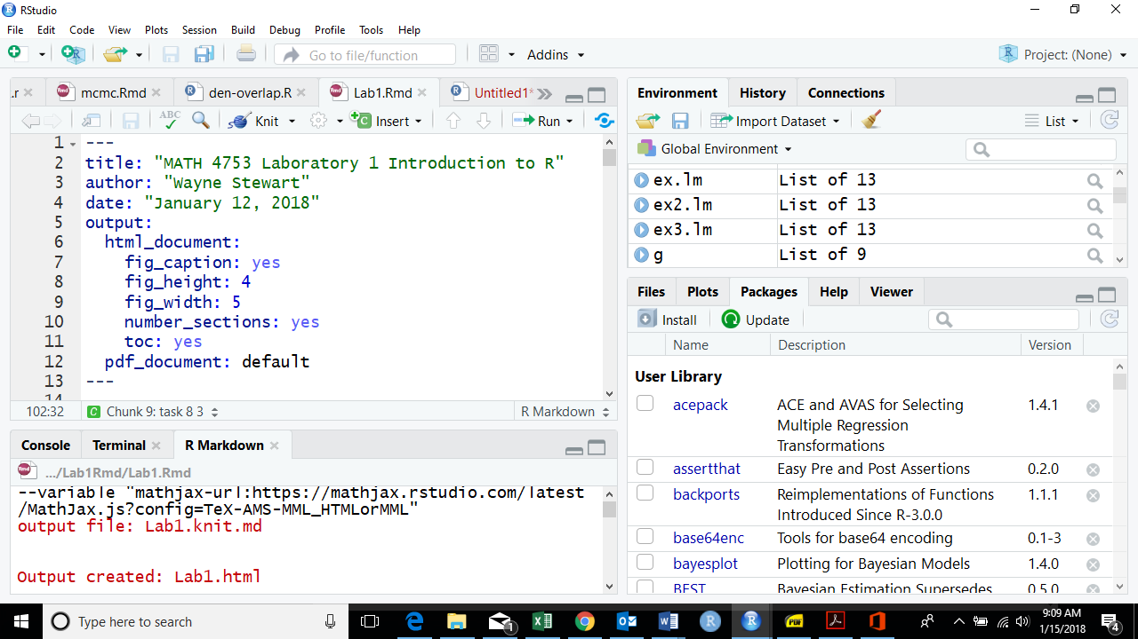

* + Obtain the first six lines of the data using “head()”:
* Task 3
  + We read the data into an object called “ddt”. This object contains all of the data. What are the qualitative variables in “ddt”?
  + What are the quantitative variables in “ddt”?
  + How many SPECIES are in the ddt data set?
  + Subset the ddt data set so that we see only the observations with SPECIES, LMBASS and WEIGHT bigger than 800gms
  + Subset the ddt data set so that we see only those observations where the RIVER is SCM and DDT bigger than 4.0
* CLICKER QUESTIONS (these are to be answered below since most will not have a clicker yet)

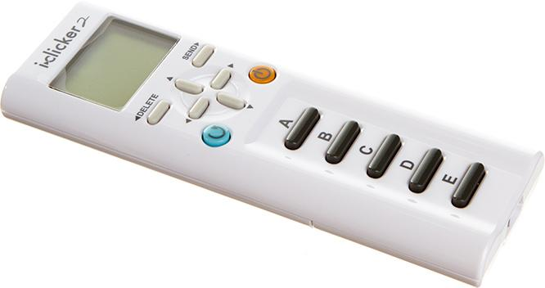

|  |  |
| --- | --- |
| Q.1 Find the mean length of fish in the ddt data frame! | Ans. |
| Q.2 What is the standard deviation of the weight of fish in the ddt data frame? | Ans. |
| Q3. Is this the plot of LENGTH vs WEIGHT from the ddt data frame? | Ans. 1=Yes, 0=No |
| Q4. If v=1:20 what is the last value of v/20? | Ans. |

* Task 4
  + Make a table of the rivers.
  + Make a color coded barplot of the rivers.
  + Make a table of the rivers crossed with the species of fish.
  + Make a barplot of the rivers crossed with the species of fish.
* Task 5
  + Make a pie chart of Fish SPECIES
  + Make a pie chart of RIVERS
* Task 6
  + Make a boxplot of the variable DDT
  + Make a boxplot of the variable WEIGHT
  + Make a boxplot of the variable LENGTH
* Task 7
  + Make a coplot of LENGTH Vs WEIGHT given RIVER
  + Make a coplot of DDT Vs WEIGHT given SPECIES
* Task 8 Make sure all code is placed in with your answers!
  + Use ggplot and make the following boxplots (be sure to put your name on the title using ggtitle())

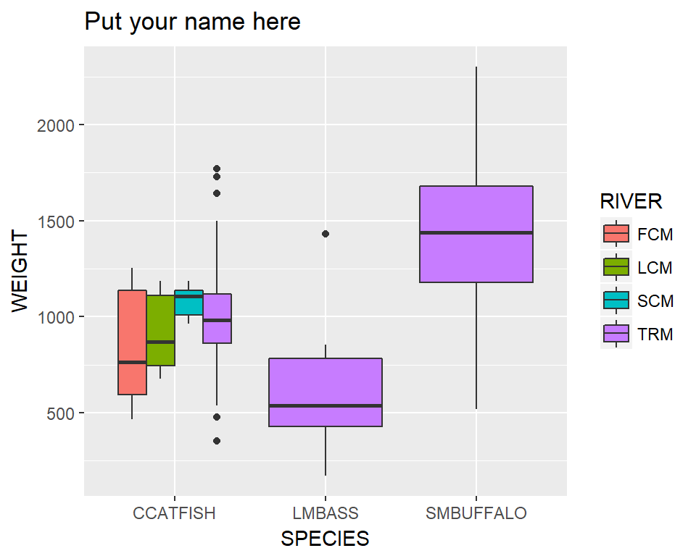

* + Use ggplot and make the following violin plots (name on the title)

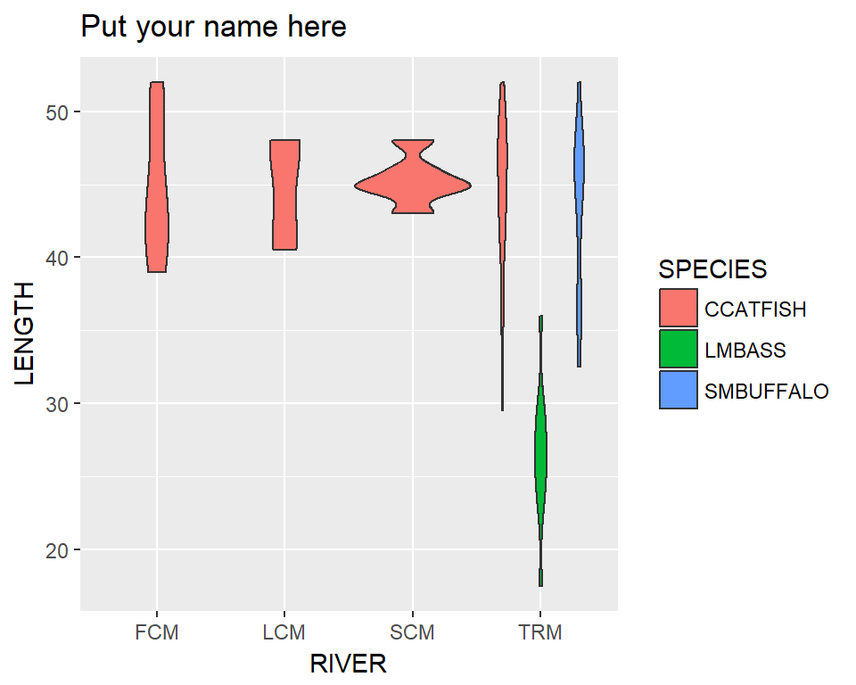

* + Use ggplot and make the following scatter plots (name on the title)

